AREA: Conversion-BP-Line Protection Screen
JIRA: ATP-10577
DESCRIPTION:
P00008244-Q0104912
While navigating from Line Protection-Alert message displayed as “Please Select Taken Or Not Taken From Situation (Address)”
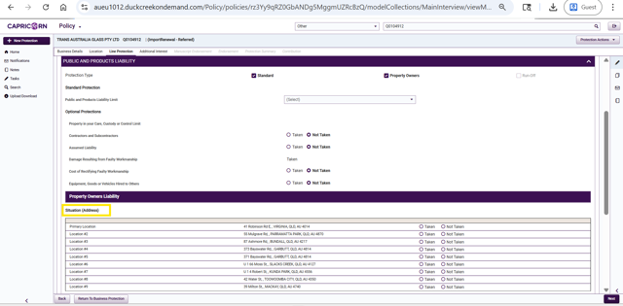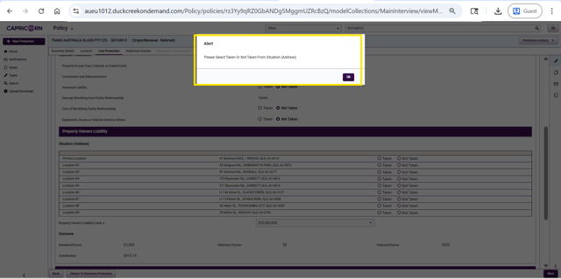
COMMENTS:
1. Ranjitha S — Created the Work Item — Issue created
2. Ranjitha S — Updated Link — This work item Dependent on ATP-5998
3. Ranjitha S — Updated Description — P00008244-Q0104912 While navigating from Line Protection-Alert message displayed as "Please Select Taken Or Not Taken From Situation (Address)"
4. Ranjitha S — Added Attachment — image-20260514-123108.png
5. Ranjitha S — Added Attachment — image-20260514-123143.png
6. Ranjitha S — Added Comment — Bug has been raised for Conversion-BP-Line Protection Screen. cc: Naga Mallikarjun, Kothari S S Nagavalli, Rajesh Devara, Namburi Rishitha
7. Ranjitha S — Updated Product — DC Data & Reporting
8. Ranjitha S — Updated Labels — Added: policy_conversion
9. Ranjitha S — Changed Assignee — Ranjitha S → Vihari Nallabothula
10. Vihari Nallabothula — Changed Assignee — Vihari Nallabothula → Keerthana
11. Keerthana — Changed Assignee — Keerthana → Raju Kallepelli
12. Namburi Rishitha — Changed Status — Backlog → To Do
STATUS: To Do
AREA: BP - AU - Location Screen- Mandatory fields value is not populating
JIRA: ATP-10810
DESCRIPTION: Observation: Data is not populating from the source as the values are empty in the source.
POT:
UI:
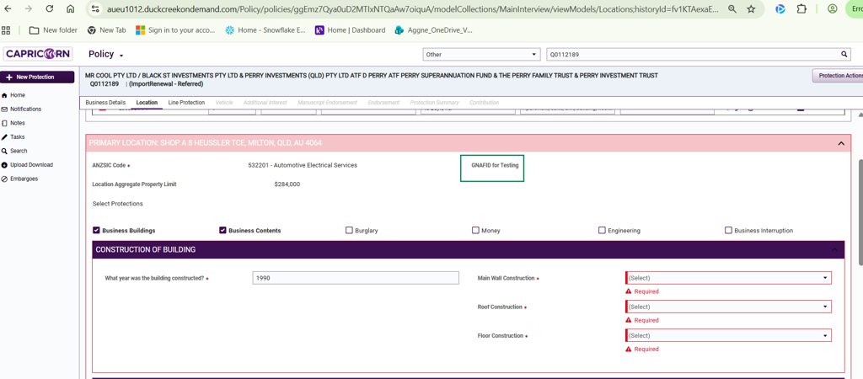
COMMENTS:
1. Kothari S S Nagavalli — Created the Work Item — Issue created
2. Kothari S S Nagavalli — Updated Link — This work item Dependent on ATP-5998
3. Kothari S S Nagavalli — Added Attachment — Request - P00029944.xml
4. Kothari S S Nagavalli — Added Attachment — Request - P00029944 (a852245b-8f60-4c34-b485-717977217916).xml
5. Kothari S S Nagavalli — Added Attachment — Res- P00029944.xml
6. Kothari S S Nagavalli — Updated Labels — Added: policy_conversion
7. Namburi Rishitha — Changed Status — Backlog → To Do
STATUS: To Do

AREA: Policy conversion defect - Business details screen - Primary and secondary ANZSIC different to SAS logic provided Q0114266/P00034478, P00015080/Q0114257
JIRA: ATP-11069
DESCRIPTION:
tested on 1st September batch sent on Jul 7, 2026
ISSUE
- different ANZSIC code used hence other fields under UI being populated unnecessarily. for Q0114266
- i reckon the SAS code below is not being applied or working hence we are getting ANZSIC for primary Q0114257 and if thats fixed then secondary ANZSIC should also work?
Question:
I am retrieving primary anzsic code as 222222 whereas DC is getting 774101 which I reckon is happening because the code below might not be correct.
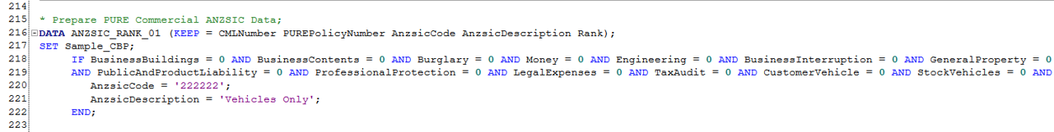
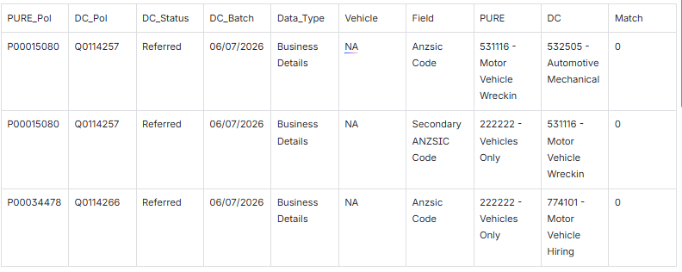
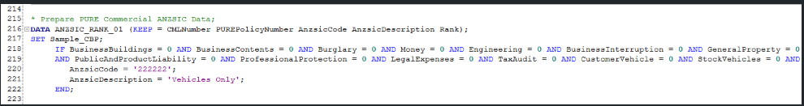
COMMENTS:
- Jilna Rajesh — Created the work item (last week)
- Jilna Rajesh — Changed Parent from None to ATP-10219 (last week)
- Jilna Rajesh — Updated Description — Added initial description with ANZSIC code mismatch details for P00034478/Q0114266 and attached image reference (last week)
- Jilna Rajesh — Added Attachment — image-20260707-043121.png (last week)
- Jilna Rajesh — Updated Description — Added second policy P00015080/Q0114257 with ANZSIC code mismatch (531116 vs 532505) to the table (last week)
- Jilna Rajesh — Added Comment — Tagged Raju Kallepelli asking why primary ANZSIC code differs; noted editing on Jul 8 to add secondary ANZSIC issue for P00015080; also tagged Maeveline Kamili and saichand patha (last week, edited)
- Jilna Rajesh — Updated Summary — Changed from "fdsfsd" to "Policy conversion defect - Business details screen - Primary ANZSIC different to SAS logic provided Q0114294/P00034537" (last week)
- Jilna Rajesh — Updated Summary — Changed policy references from Q0114294/P00034537 to Q0114294/P00034478 (last week)
- Jilna Rajesh — Updated Summary — Changed from Q0114294/P00034478 to Q0114266/P00034478 (last week)
- Jilna Rajesh — Changed Assignee — From Unassigned to Raju Kallepelli (last week)
- Jilna Rajesh — Updated Labels — Added "policy_conversion" (last week)
- Jilna Rajesh — Updated Description — Reformatted issues as numbered list: #1 different ANZSIC code for Q0114266, #2 SAS code not being applied for Q0114257 (last week)
- Jilna Rajesh — Updated Summary — Appended ", P00015080/Q0114257" to include second policy pair (last week)
- Jilna Rajesh — Added Attachment — image-20260707-044147.png (last week)
- Jilna Rajesh — Updated Summary — Changed "Primary ANZSIC" to "Primary and secondary ANZSIC" (last week)
- Jilna Rajesh — Updated Description — Added secondary ANZSIC row for P00015080/Q0114257 (222222 vs 531116) and added question about whether fixing primary will also fix secondary (last week)
- Shinjita Pani — Changed Status — From Backlog to To Do (last week)
- Jilna Rajesh — Changed Priority — From Highest to High (4 days ago)
- Raju Kallepelli — Changed Status — From To Do to In Progress (2 days ago)
STATUS: IN progress
AREA: Renewal - Policy Conversion - Manual referral text not populating correctly
JIRA: ATP-11086
DESCRIPTION: When migrating the manual referral condition from PURE to DC the referral text is not populating in all instances.
REF: Q0112135
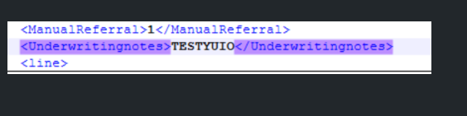
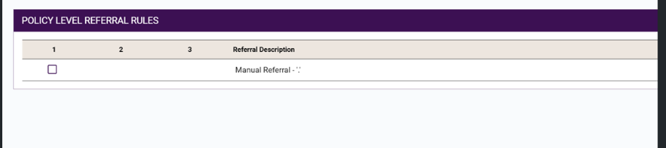
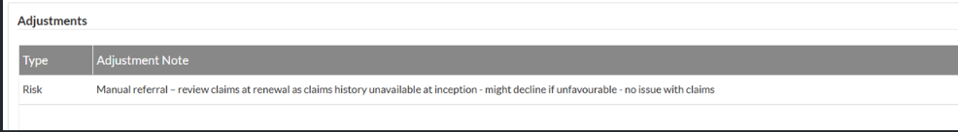
COMMENTS:
# | User | Action | Details
1 | Simon Gardiner | Created Work Item | Created last week
2 | Simon Gardiner | Changed Parent | None → ATP-10219
3 | Simon Gardiner | Updated Product | None → DC Policy
4 | Simon Gardiner | Updated Labels | None → Renewal, policy_conversion
5 | Simon Gardiner | Updated Description | None → "When migrating the manual referral condition from PURE to DC the referral text is not populating in all instances."
6 | Simon Gardiner | Updated Description | Added "REF: Q0112135" to existing description
7 | Simon Gardiner | Added Attachment | image-20260708-003655.png
8 | Simon Gardiner | Added Attachment | image-20260708-003700.png
9 | Simon Gardiner | Changed Priority | Highest → Medium
10 | Simon Gardiner | Changed Assignee | Unassigned → Shinjita Pani
11 | Shinjita Pani | Changed Assignee | Shinjita Pani → Akash Jain
12 | Shinjita Pani | Added Comment | "Hi Akash Jain can you please look into it."
13 | Shinjita Pani | Changed Status | Backlog → To Do
14 | Sahithi Gudla | Added Attachment | image-20260709-144857.png
15 | Sahithi Gudla | Added Comment | "Hi Raju Kallepelli – We have validated the payload and observed that the text associated with the Manual Referral rule is not being provided. The node <Underwritingnotes></Underwritingnotes> is missing from the payload. Please ensure this node is included. CC: Vihari Nallabothula"
16 | Sahithi Gudla | Changed Status | To Do → In Progress
17 | Sahithi Gudla | Changed Status | In Progress → To Do
18 | Sahithi Gudla | Changed Assignee | Akash Jain → Raju Kallepelli
19 | Raju Kallepelli | Changed Status | To Do → In Progress
STATUS:IN PROGRESS

AREA: Policy conversion defect - CM details: Incorrect value for Agreed Value without Accessories in UI + Clarity
JIRA : ATP-11118
DESCRIPTION:
Tested on 09072026, 1st September Batch (06JUL2026) and these policies are retrieving wrong values for Agreed Value Without Accessories in UI + Clarity.
It seems that values from PURE have been migrated without taking into consideration the depreciation requirement.
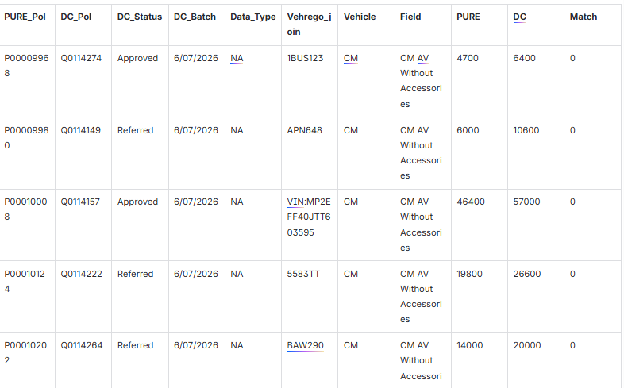
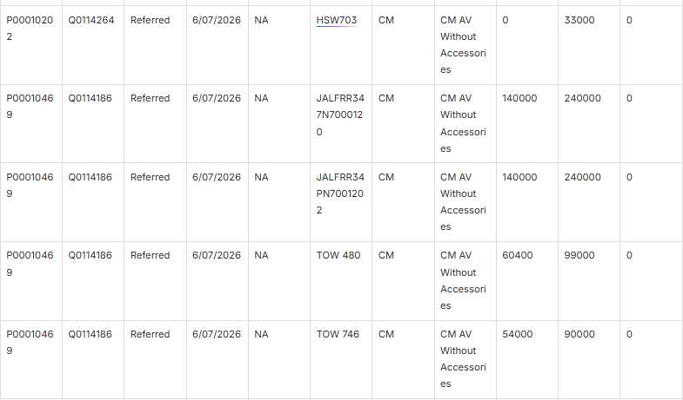
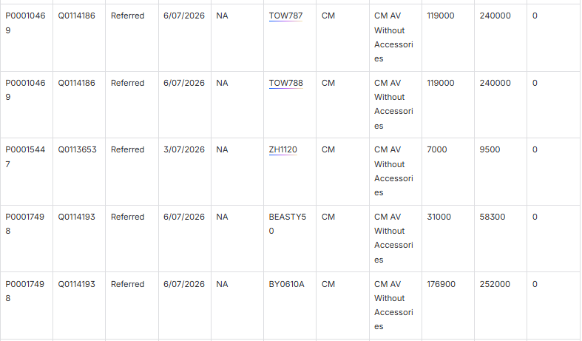
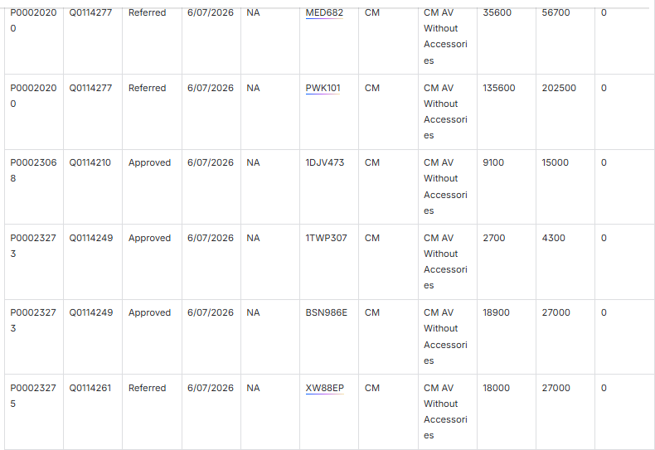
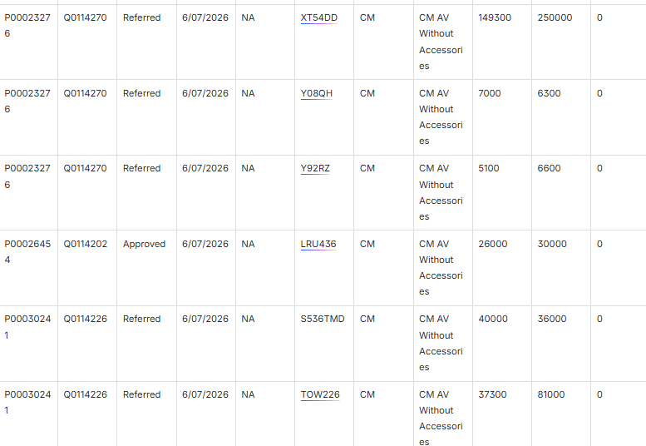
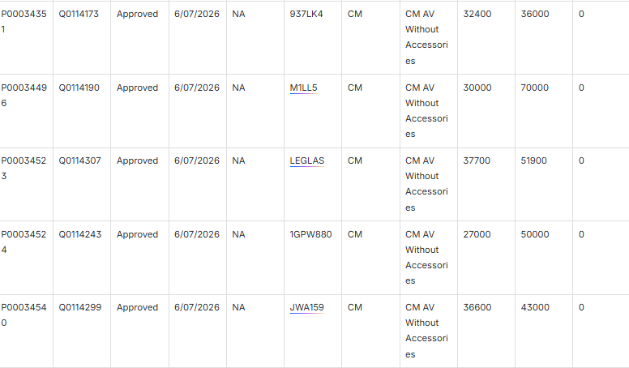

COMMENTS:
- Maeveline Kamili — Created the Work item — Last week
- Maeveline Kamili — Changed the Parent — From None to ATP-10219
- Maeveline Kamili — Updated the Description — Added initial table of policies with wrong "Agreed Value Without Accessories" values
- Simon Gardiner — Changed the Priority — From Highest to High
- Maeveline Kamili — Updated the Description — Added root cause note: "values from PURE have been migrated without taking into consideration the depreciation requirement"
- Maeveline Kamili — Added an Attachment — image-20260709-024321.png
- Maeveline Kamili — Added a Comment — Explained calculation for Q0114274 - 1BUS123: AV without accessories = 4702.6,
Value Ratio = 0.63, Depreciation Rate = 0%, expected 4700 but UI + Clarity showing 6400. CC'd Jilna Rajesh, Omer Shehzad, Raju Kallepelli, saichand patha
- Maeveline Kamili — Changed the Assignee — From Unassigned to Raju Kallepelli
- Maeveline Kamili — Updated the Labels — From None to policy_conversion
- Shinjita Pani — Changed the Status — From Backlog to To Do
- Raju Kallepelli — Changed the Assignee — From Raju Kallepelli to Vihari Nallabothula
- Vihari Nallabothula — Added a Comment — "Raju Kallepelli we see incorrect values passed for Agreed value, please check"
- Vihari Nallabothula — Changed the Assignee — From Vihari Nallabothula to Raju Kallepelli
- Vihari Nallabothula — Changed the Status — From To Do to In Progress
STATUS: IN PROGRESS
AREA:
Policy conversion defect - Fleet Details Screen: "Market Value without accessories" broken in UI + Clarity

JIRA: ATP-11129
DESCRIPTION: Tested on 09072026, 1st September Batch (06JUL2026) and in Fleet Details Screen, “Market Value without accessories" is not retrieving values in UI + Clarity.
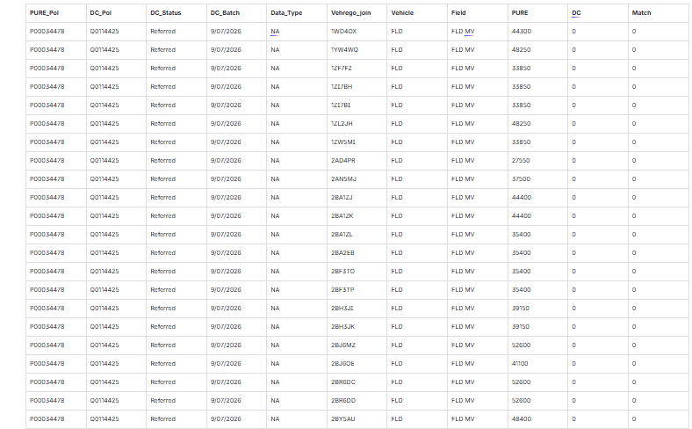
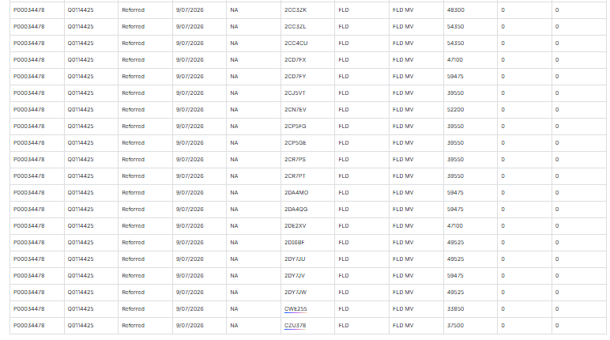
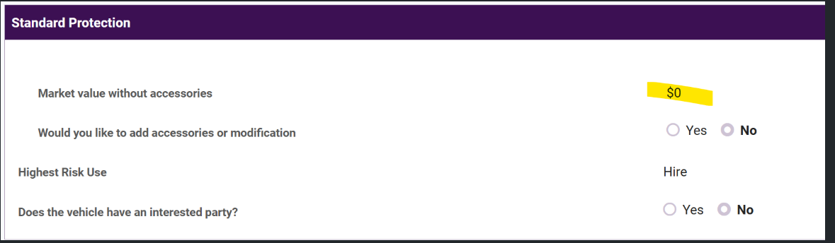
COMMENTS:
- Maeveline Kamili — Created the Work item — last week
- Maeveline Kamili — Changed the Parent — from None to ATP-10219
- Maeveline Kamili — Updated the Summary — from "Policy conversion defect - Fleet Detail Screen: "Market Value without accessories" broken in UI + Clarity" to "Policy conversion defect - Fleet Details Screen: "Market Value without accessories" broken in UI + Clarity"
- Maeveline Kamili — Updated the Description — Added details: Tested on 09072026, 1st September Batch (06JUL2026) and in Fleet Details Screen, "Market Value without accessories" is not retrieving values in UI + Clarity. Includes data table for policy P00034478 / DC_Pol Q0114425 (Referred status, 9/07/2026 batch) with 42 vehicle registrations showing FLD MV values from PURE (ranging 27,550–59,475) but DC returning 0 for all.
- Maeveline Kamili — Added an Attachment — image-20260709-062825.png
- Maeveline Kamili — Added a Comment — "Ex: Q0114425 - 1WD4OX. Not retrieving value even when reference table (for PURE) has values." cc: Jilna Rajesh, Omer Shehzad, Raju Kallepelli, saichand patha
- Maeveline Kamili — Changed the Assignee — from Unassigned to Raju Kallepelli
- Maeveline Kamili — Updated the Labels — from None to policy_conversion
- Maeveline Kamili — Changed the Priority — from Highest to High
- Shinjita Pani — Changed the Status — from Backlog to To Do
STATUS: To Do
AREA: Policy conversion defect - CM details: Missing Clauses in UI + Clarity
JIRA: ATP-11149
DESCRIPTION: Tested on 10072026, 1st September Batch (06JUL2026) and Q0114570 - DDN699 is missing its clauses when it’s supposed to have a clause.
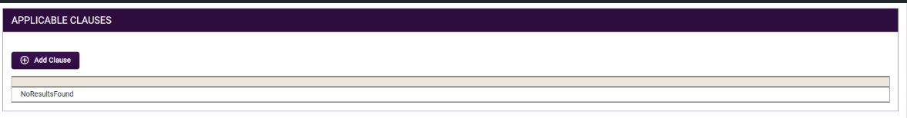
COMMENTS:
- Maeveline Kamili — Created the Work item — 4 days ago
- Maeveline Kamili — Changed the Parent — from None to ATP-10219
- Maeveline Kamili — Updated the Description — Added: "Tested on 10072026, 1st September Batch (06JUL2026) and Q0114570 - DDN699 is missing its clauses when it's supposed to have a clause."
- Maeveline Kamili — Added an Attachment — image-20260710-041513.png
- Maeveline Kamili — Added an Attachment — image-20260710-041527.png
- Maeveline Kamili — Added a Comment — "Example Q0114570 - DDN699 does not have any clauses in the UI + Clarity, when it's supposed to have 1." cc: Jilna Rajesh, Omer Shehzad, Raju Kallepelli, saichand patha
- Maeveline Kamili — Changed the Assignee — from Unassigned to Raju Kallepelli
- Maeveline Kamili — Updated the Labels — from None to policy_conversion
- Maeveline Kamili — Changed the Priority — from Highest to High
- Maeveline Kamili — Updated the Summary — from "Policy conversion defect - CM details: Missing Clauses in UI + Clarity" to "Policy conversion defect - CM details: Missing Clauses in UI"
- Maeveline Kamili — Updated the Summary — from "Policy conversion defect - CM details: Missing Clauses in UI" to "Policy conversion defect - CM details: Missing Clauses in UI + Clarity"

STATUS: BACKLOG
AREA: Policy conversion defect - Additional Interest Screen: some interested parties missing on UI + Clarity
JIRA: ATP-11175
DESCRIPTION:
Tested on Sept batch sent on Jul 14, 2026
ISSUE:additional interested parties missing for below protections: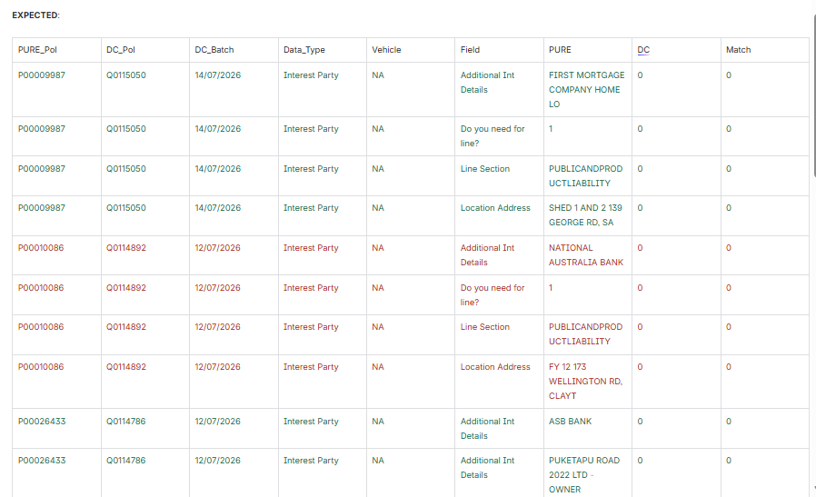
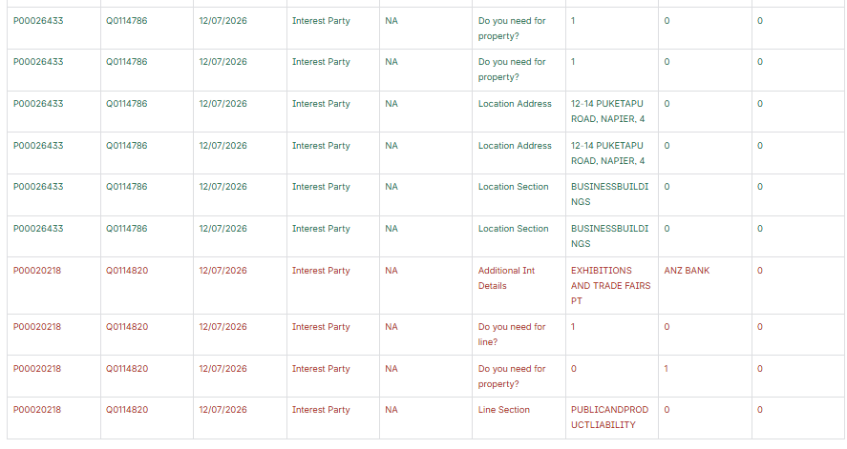
COMMENTS:
- User: Jilna Rajesh
Action: Created the Work item
Details: Created ticket ATP-11175 (9 hours ago)
- User: Jilna Rajesh
Action: Changed the Parent
Details: Parent changed from None → ATP-10219
- User: Jilna Rajesh
Action: Updated the Description
Details: Added initial description — "Tested on Sept batch sent on 2026-07-14. ISSUE: additional interested parties missing for below protections" with mismatch data for policies P00009987/Q0115050, P00010086/Q0114892, P00026433/Q0114786, P00020218/Q0114820
- User: Jilna Rajesh
Action: Updated the Description (2nd edit)
Details: Added "EXPECTED:" label before the data table
- User: Jilna Rajesh
Action: Updated the Description (3rd edit)
Details: Added additional rows for P00020218/Q0114820 — "Do you need for line?" (PURE=1, DC=0, Match=0)
- User: Jilna Rajesh
Action: Updated the Description (4th edit)
Details: Added row for P00020218/Q0114820 — "Do you need for property?" (PURE=0, DC=1, Match=0)
- User: Jilna Rajesh
Action: Updated the Description (5th edit)
Details: Added row for P00020218/Q0114820 — "Line Section" = PUBLICANDPRODUCTLIABILITY (PURE value present, DC=0, Match=0)
- User: Jilna Rajesh
Action: Added a Comment
Details: Tagged Raju Kallepelli asking "Can we please check why this information is missing in UI?" and noted that since interested party is missing, all subsequent fields are mismatched. Also tagged Maeveline Kamili and saichand patha.
- User: Jilna Rajesh
Action: Changed the Assignee
Details: Assignee changed from Unassigned → Raju Kallepelli
- User: Jilna Rajesh
Action: Changed the Priority
Details: Priority changed from Highest → High
- User: Jilna Rajesh
Action: Updated the Labels
Details: Labels changed from None → policy_conversion
STATUS: BACKLOG
AREA: Policy Conversion defect - Missing CML00006306 in V_CAP_PARTY_DATA
JIRA: ATP-11179
DESCRIPTION: tested on 14072026, 1st September Batch (14JUL2026) and CML00006306 is still missing in V_CAP_PARTY_DATA.
COMMENTS:
- User: Maeveline Kamili
Action: Created the Work item
Details: Created ticket ATP-11179 (6 hours ago)
- User: Maeveline Kamili
Action: Changed the Parent
Details: Parent changed from None → ATP-10219
- User: Maeveline Kamili
Action: Updated the Description
Details: Description changed from None → "Tested on 14072026, 1st September Batch (14JUL2026) and CML00006306 is still missing in V_CAP_PARTY_DATA."
- User: Maeveline Kamili
Action: Changed the Assignee
Details: Assignee changed from Unassigned → Raju Kallepelli
- User: Maeveline Kamili
Action: Updated the Labels
Details: Labels changed from None → policy_conversion
- User: Maeveline Kamili
Action: Added a Comment
Details: "Hey Raju Kallepelli, Logging it into a bug so you can keep track, but CML00006306 is still missing in V_CAP_PARTY_DATA as of today." cc: Jilna Rajesh, Omer Shehzad, Raju Kallepelli, saichand patha
- User: Maeveline Kamili
Action: Changed the Priority
Details: Priority changed (new value not specified in the history)
STATUS: Backlog

